LATINSUMMER
Ancient Greek Language Curriculum

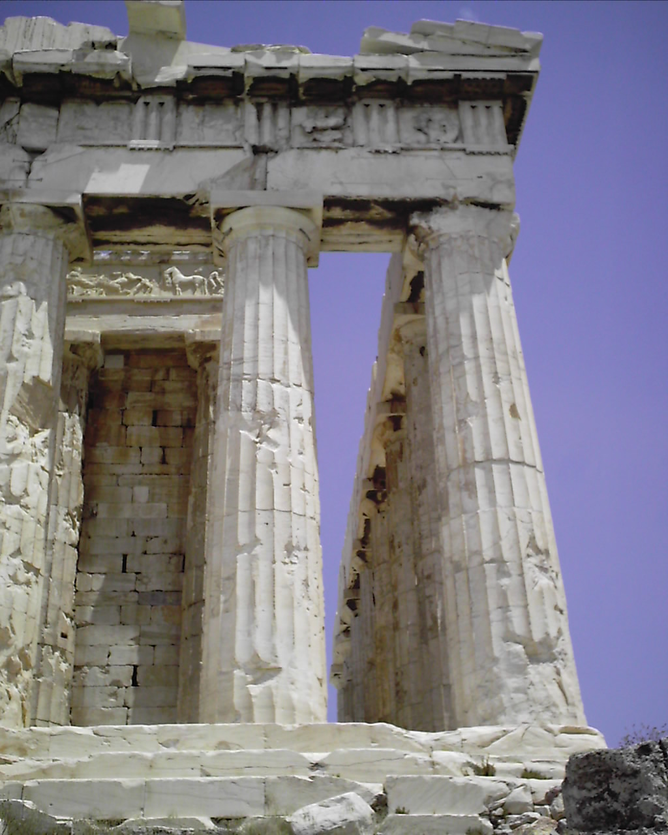
The Parthenon in Athens, Greece

© 2006 Matthew D. Webb & Ascanius: The Youth Classics Institute
LATINSUMMER
Ancient Greek Language Curriculum
Day 1: Adjectives

Materials

adjectives pictures on card-stock
animals (stuffed)
dowel rods (thick)
markers
mini-sandboxes (tupperware trays, sand)
overhead of ancient Greek writing
overhead of the ancient Mediterranean
white paper

Procedures

Introduction to Greece and the Greeks
1. Assess student knowledge of Greece and the Greeks:
Where is Greece? Who are the Greeks? What do you know about them, their country, their accomplishments? Compare the Greeks to the ancient Romans.

Use an overhead of the ancient Mediterranean to help orient students to the location of Greece vs. the location of Italy.

The Alphabet
2. Show an overhead of ancient Greek writing to give the students a taste of what the alphabet looks like.

3. Teach and practice: α β γ δ ε ζ
Write letters on board one at a time.
Students use mini-sandboxes and thick dowel rods to practice writing the letters.
Explain that this is similar to the method actual ancient Greek children used to learn the
alphabet.
Put up overheads of letters; students must say the name and sound out the letter as
quickly as possible.
Sing the appropriate portion of the Greek alphabet song.
Reveal the appropriate letters on the wall.

Adjectives
4. Teach and practice the adjectives, via pictures, orally.
Show students the adjectives pictures.
Say the appropriate Greek word for each picture.
Have the students repeat after you.
Go through the pictures again and have the students recall the Greek words.
Ask the class to raise their hands if they are the various adjectives.
Go around the class asking one by one, who is adjective (τις εστι …)?
Then make it a statement, and have the class repeat.

5. Picture dictation using white paper and markers with adjectives and animals. Hold up stuffed animals, describe them in Greek using the adjectives.
LATINSUMMER
Ancient Greek Language Curriculum
Day 2: Animals

Materials

animals (stuffed) – goat, cow, horse, pig, cat, frog, bird, dog
dowel rods (thick)
mini-sandboxes (tupperware trays, sand)
overheads of letters
PowerPoint – Adjectives & Animals Review (Squares)
PowerPoint – Animals Review (Sounds)

Procedures

The Alphabet
1. Teach and practice: η θ ι κ λ μ
Write letters on board one at a time.
Students use mini-sandboxes and thick dowel rods to practice writing the letters.
Explain that this is similar to the method actual ancient Greek children used to learn the
alphabet.
Put up overheads of letters; students must say the name and sound out the letter as
quickly as possible.
Sing the appropriate portion of the Greek alphabet song.
Reveal the appropriate letters on the wall.

Animals
2. Teach and practice the animals, via stuffed animals, orally.
Show students the stuffed animals.
Say the appropriate Greek word (plus εστι) for each stuffed animal.
Have the students repeat after you.
Go through the stuffed animals again and have the students recall the Greek words.
Ask the students what adjectives the animals are (‘οιος εστι …). Have the class repeat the answer.

PowerPoint Games for Practice and Review
3. Animals Review PowerPoint: guess the Greek word the animal from its noise, then picture.

4. Adjectives & Animals Review PowerPoint: Athenian Squares.

LATINSUMMER
Ancient Greek Language Curriculum
Day 3: Verbs

Materials

dowel rods (thick)
mini-sandboxes (tupperware trays, sand)
overheads of letters
sentence practice cards on card-stock

Procedures

The Alphabet
1. Teach and practice: ν ξ ο π ρ σ/ς
Write letters on board one at a time.
Students use mini-sandboxes and thick dowel rods to practice writing the letters.
Explain that this is similar to the method actual ancient Greek children used to learn the
alphabet.
Put up overheads of letters; students must say the name and sound out the letter as
quickly as possible.
Sing the appropriate portion of the Greek alphabet song.
Reveal the appropriate letters on the wall.

Verbs
2. Teach and practice the verbs orally, by enlisting the help of the students (select students before class to perform the appropriate actions when called upon).
Call on the pre-selected students to perform their actions.
Describe the action using the appropriate Greek verb.
Have the students repeat after you.
Ask the students in ancient Greek what the student is doing. (τι ποιει name…)
Simon Says game – command students to do the various verb actions. (…ε / ετε)

Sentence Practice
3. Split the students into teams of 2 and give each team a set of sentence practice cards.

4. Say sentences in Greek that consist of three words: adjective, animal, verb.

5. In teams, students form the sentences using the sentence practice cards.

LATINSUMMER
Ancient Greek Language Curriculum
Day 4: Foods

Materials

Βιγγος cards on card-stock
dowel rods (thick)
foods (plastic) – water, wine, bread, cheese, grape, olive
mini-sandboxes (tupperware trays, sand)
overheads of letters
snacks of the foods – mini water bottles, grape juice, crackers, string cheeses, grapes, olives

Procedures

The Alphabet
1. Teach and practice: τ υ φ χ ψ ω
Write letters on board one at a time.
Students use mini-sandboxes and thick dowel rods to practice writing the letters.
Explain that this is similar to the method actual ancient Greek children used to learn the
alphabet.
Put up overheads of letters; students must say the name and sound out the letter as
quickly as possible.
Sing the appropriate portion of the Greek alphabet song.
Reveal the appropriate letters on the wall.

Foods
2. Teach and practice the foods, via plastic foods, orally.
Show students the plastic foods.
Say the appropriate Greek word (plus εστι) for each plastic food.
Have the students repeat after you.
Go through the plastic foods again and have the students recall the Greek words.
Βιγγος with food terms.
Snacks if the kids can name them in Greek.

LATINSUMMER
Ancient Greek Language Curriculum
Day 5: Letters, Writing, & Review

Materials

alphabet cereal
markers
PowerPoint – Adjectives & Animals Review (Jeopardy)
PowerPoint – Verbs & Foods Review (Millionaire)
white paper

Procedures

The Alphabet
1. Review the entire alphabet.
Sing the full alphabet song several times.
Practice writing their names in Greek on white paper using markers.
Practice transliterating by forming English words with alphabet cereal and then
writing the Greek transliteration using white paper and markers.

PowerPoint Games for Practice and Review
2. Use the following PowerPoint games to practice and review. Write AND speak all terms:
Verbs & Foods Millionaire PowerPoint Game
Adjectives & Animals Jeopardy PowerPoint Game
LATINSUMMER
Ancient Greek Language Curriculum
Comprehensive Materials List

Handouts and overheads
adjectives pictures on card-stock
overhead of ancient Greek writing
overhead of the ancient Mediterranean
overheads of letters
sentence practice cards on card-stock
Βιγγος cards on card-stock

Walls
alphabet letter cards and name of letter cards on colored card-stock – 24 (cut to be interactive)
National Geo ‘The Greeks’ posters (2)
sites of Greece sections w/ place name and pics on white card-stock – 20
vocabulary cards sections by topic, with topics on white cards stock – 4 – and pics on
4 colored card-stocks – 5, 8, 5, 6 (cut to be interactive)
library sign on white cardstock

Technology
PowerPoint – Adjectives & Animals Review (Squares)
PowerPoint – Animals Review (Sounds)
PowerPoint – Adjectives & Animals Review (Jeopardy)
PowerPoint – Verbs & Foods Review (Millionaire)
laptop
LCD projector (days 2 and 5)

To buy
mini-sandbox trays (15)
sand (enough for 15 mini-sandboxes)
dowel rods, thick (15)
snacks of the foods – mini water bottles, grape juice, crackers, string cheeses, grapes, olives
alphabet cereal or cookies or gummies

Have
card-stock (44 white; 45 one color; 24 another color; 21 another color; 6 another color)
markers
white paper
animals (stuffed) – goat, cow, horse, pig, cat, frog, bird, dog
foods (plastic) – water, wine, bread, cheese, grape, olive
books on ancient Greece for classroom library
sticky tak to hang
LATINSUMMER
Ancient Greek Language Curriculum
List of Terms

Adjectives
ολβιος
επιλυτος
αγαθος
κακος
χαλεπος

Animals
κυων
τραγος
ιππος
ταυρος
χοιρος
αιλουρος
βατραχος
οιωνος

Verbs
βαινει
τρεχει
φερει
θεωρει
καλει

Foods
υδωρ
οινος
σιτος
τυρος
σταφυλη
ελαιος

writing in ancient greece
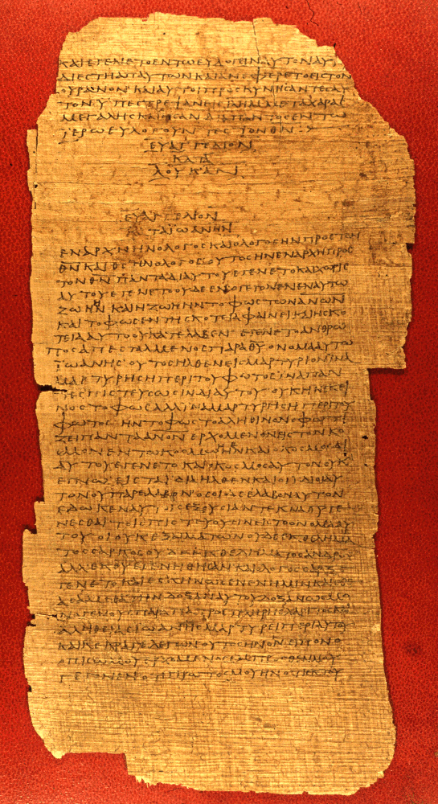

Papyrus containing portions of the Gospels of Luke and John
from 175-225 AD
(Website of Interpreting Ancient Manuscripts at the Earlham School of Religion)
Map of ancient greece

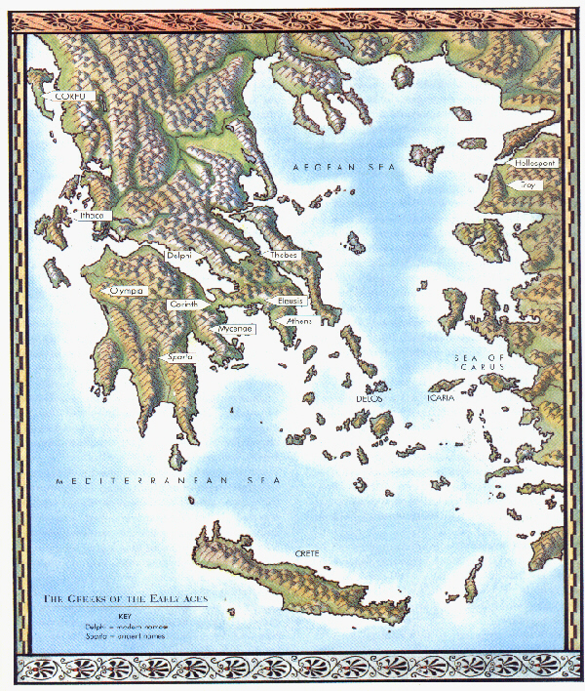
map of the
roman empire

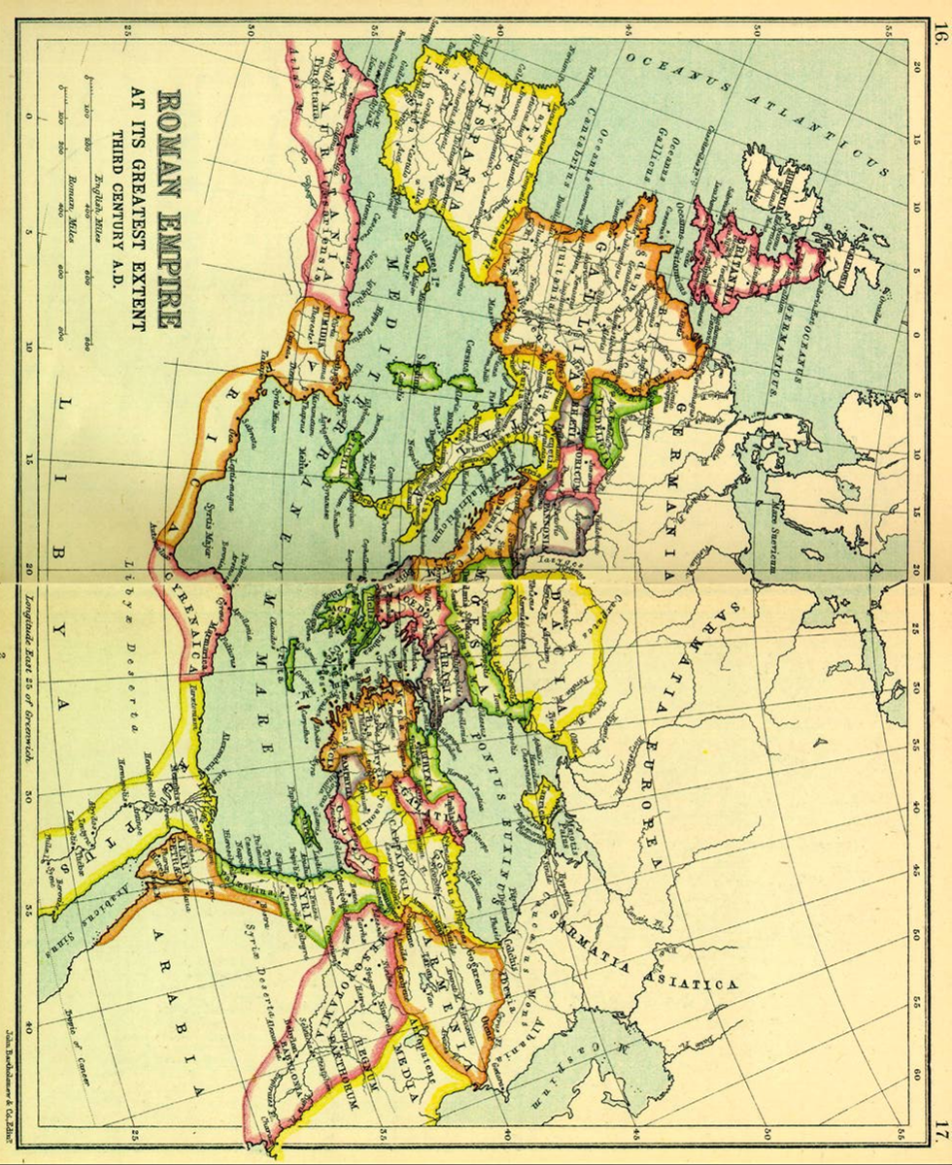

(From the University of Calgary)
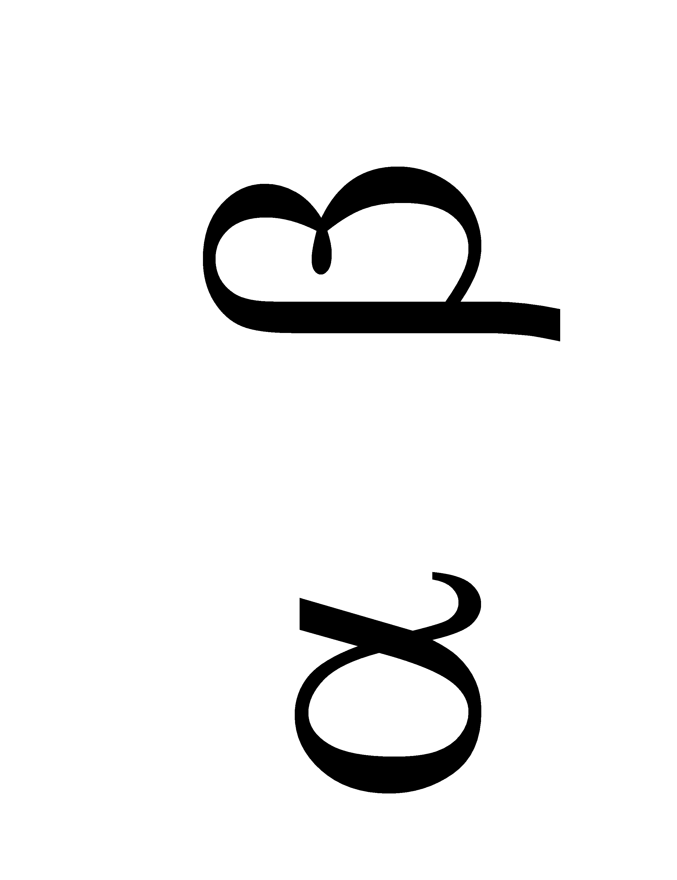

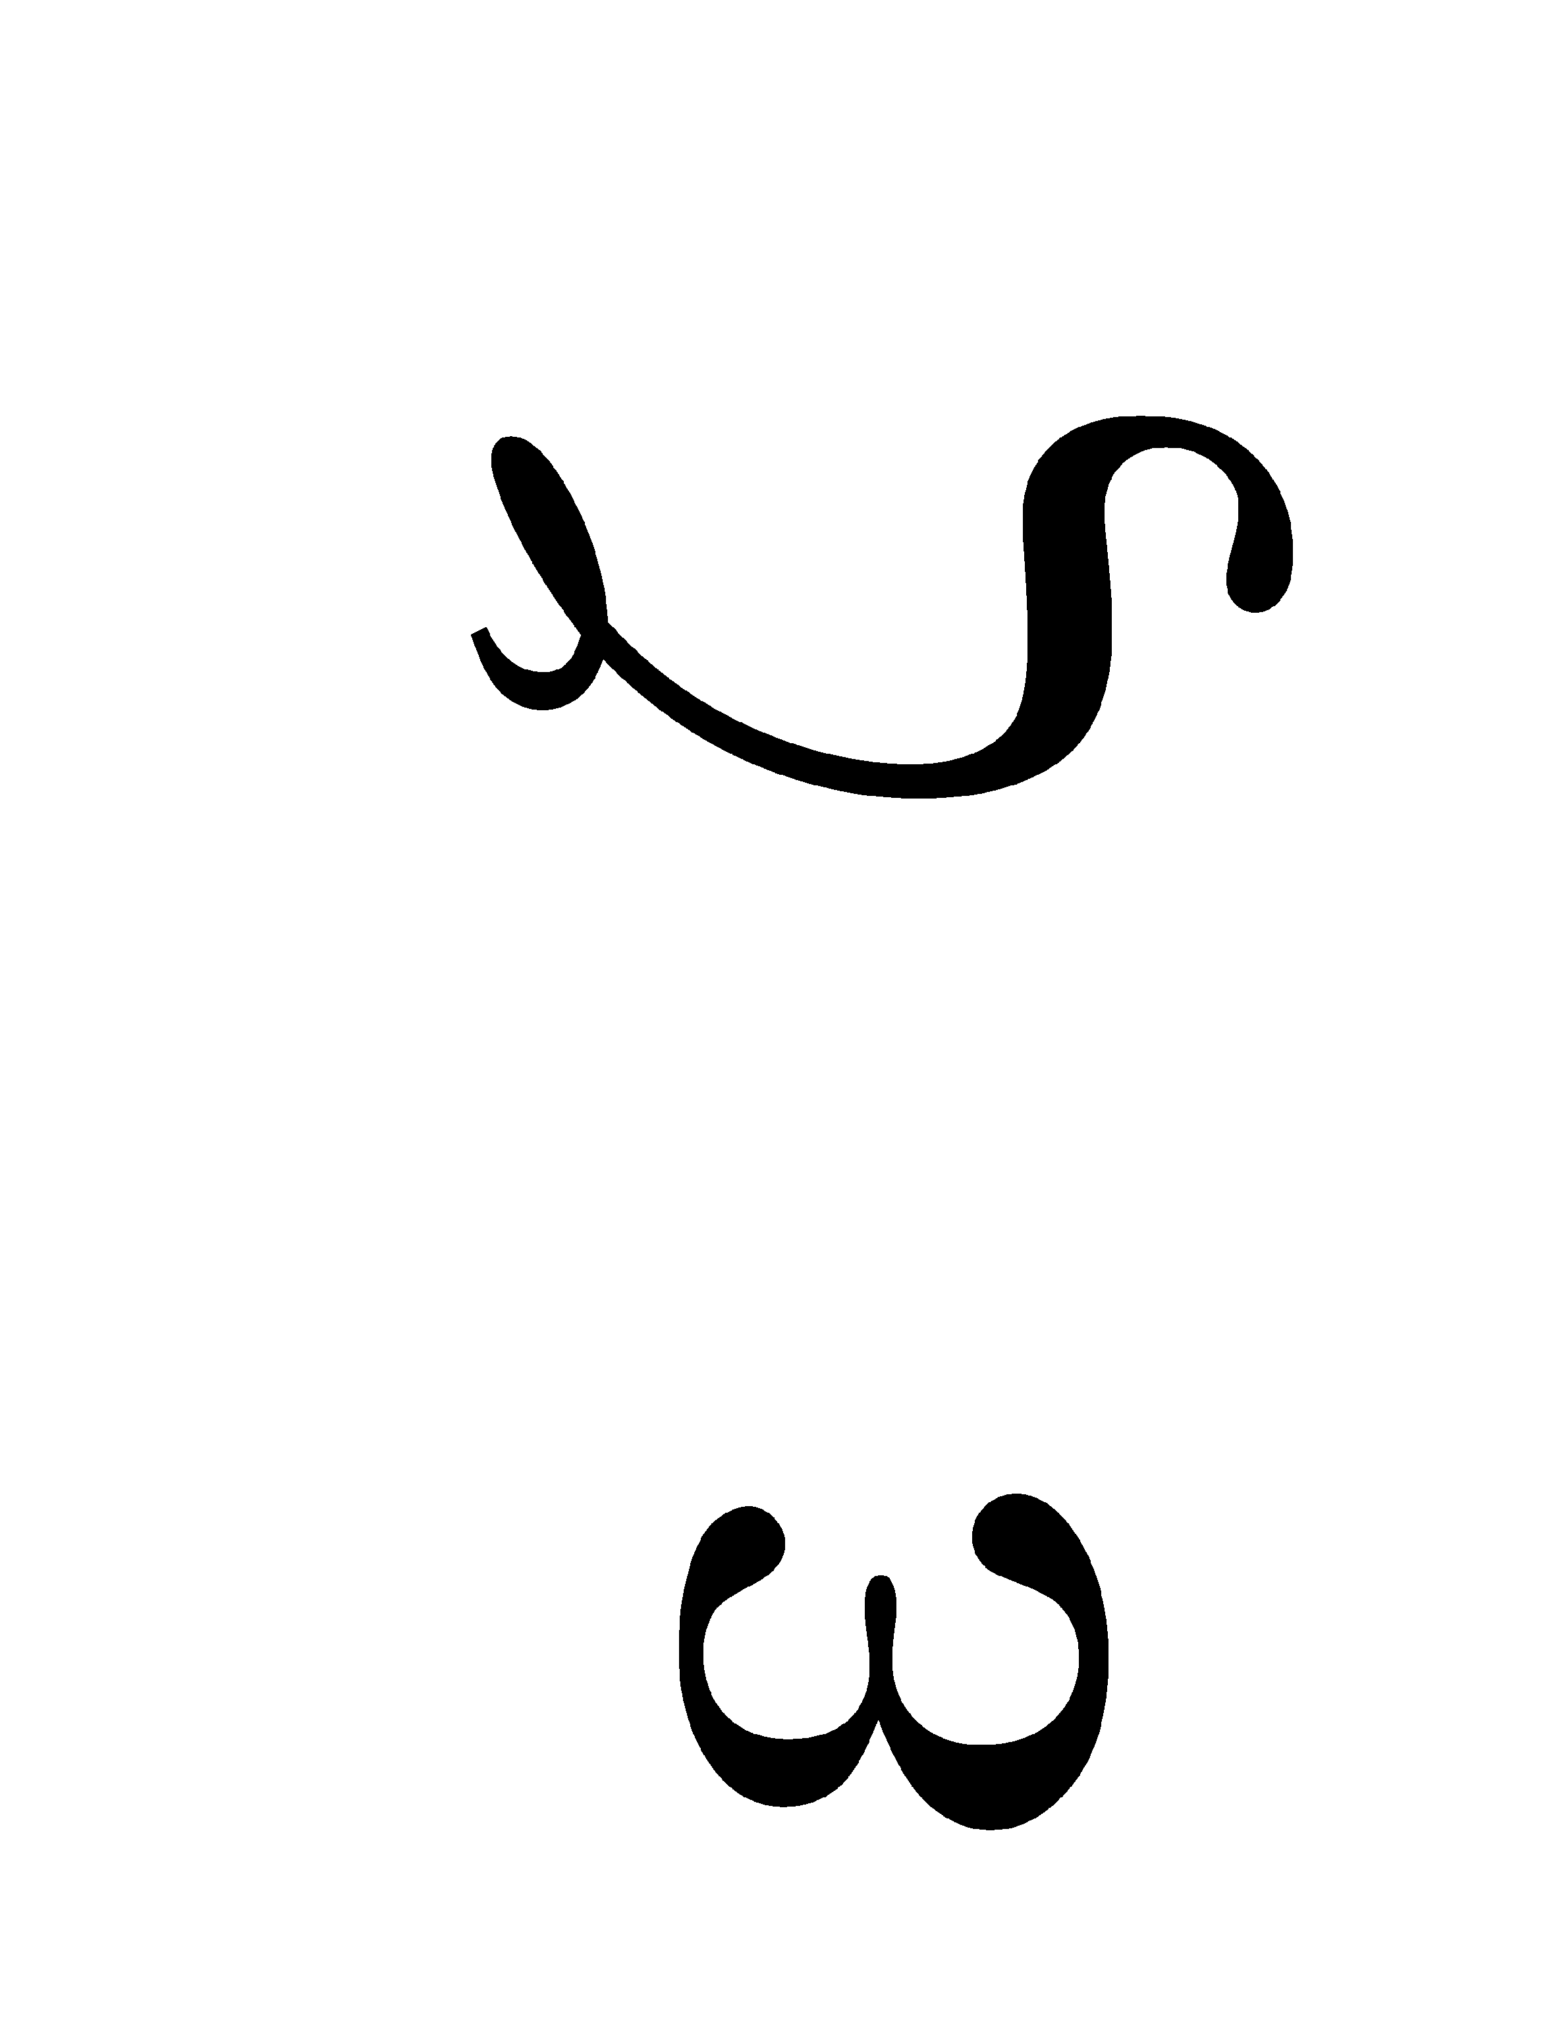
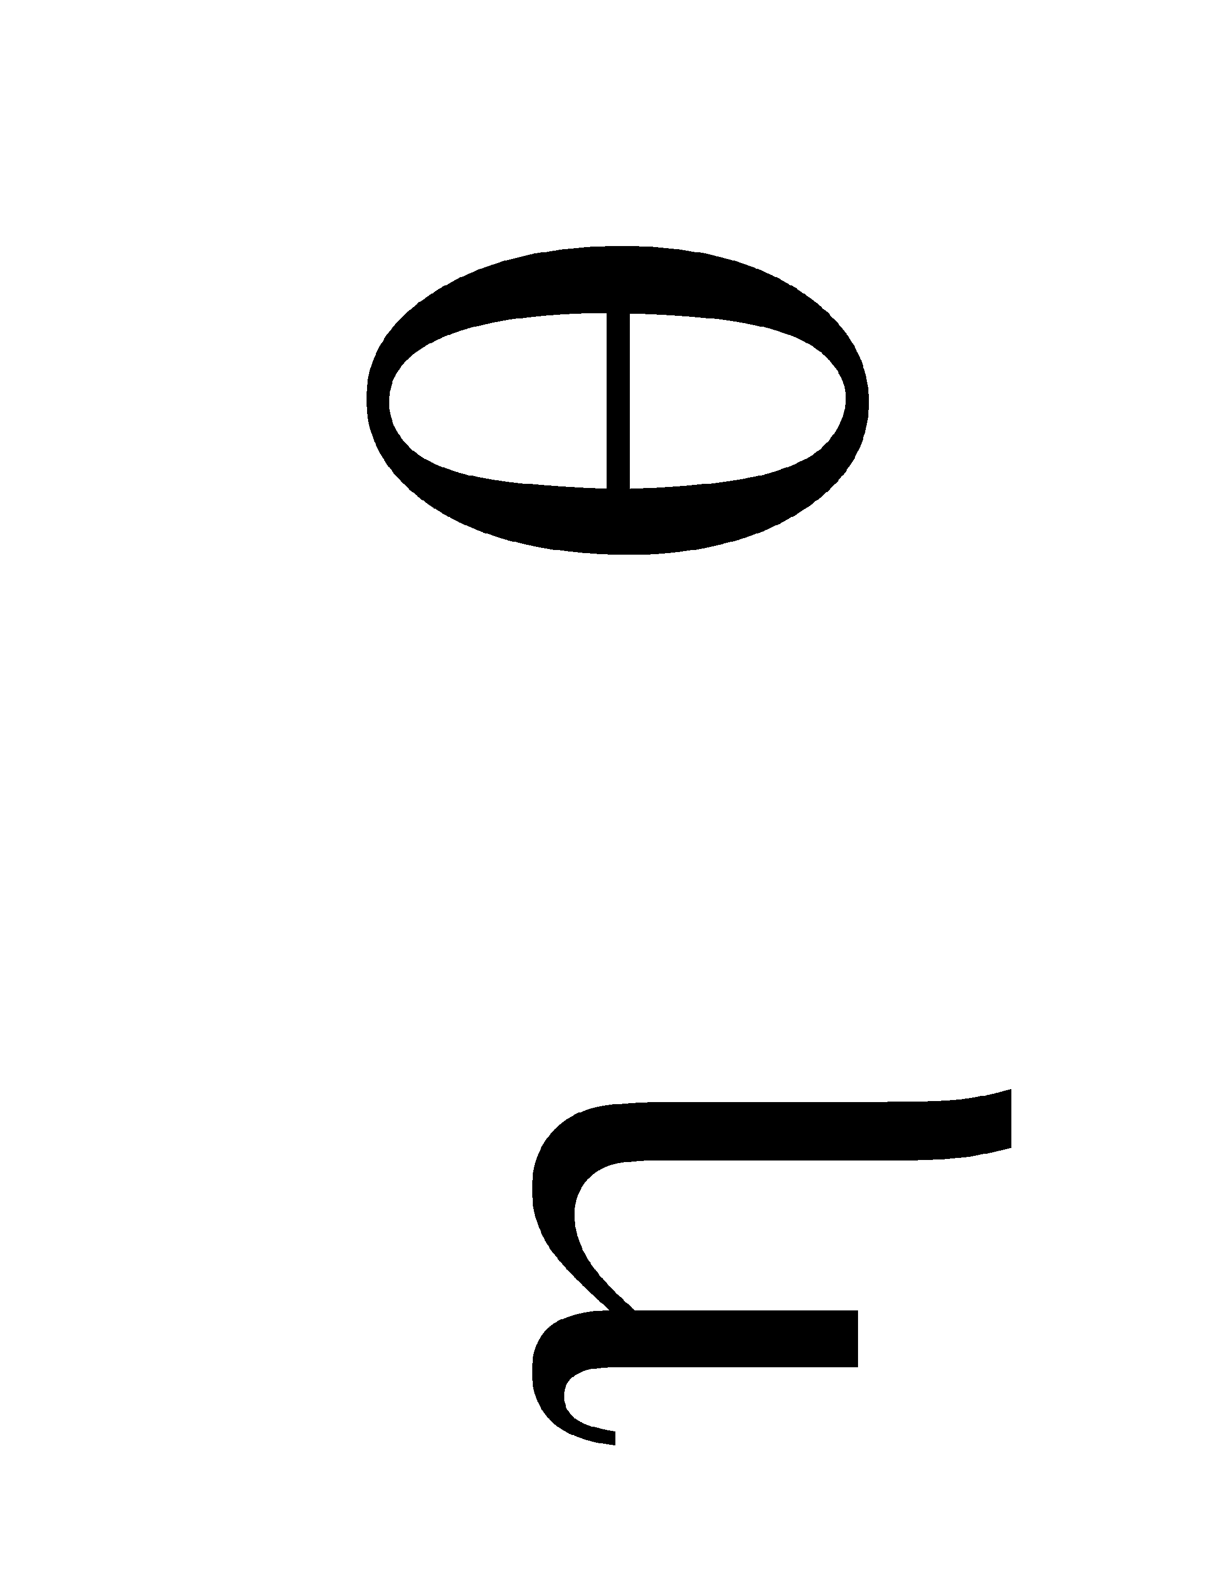
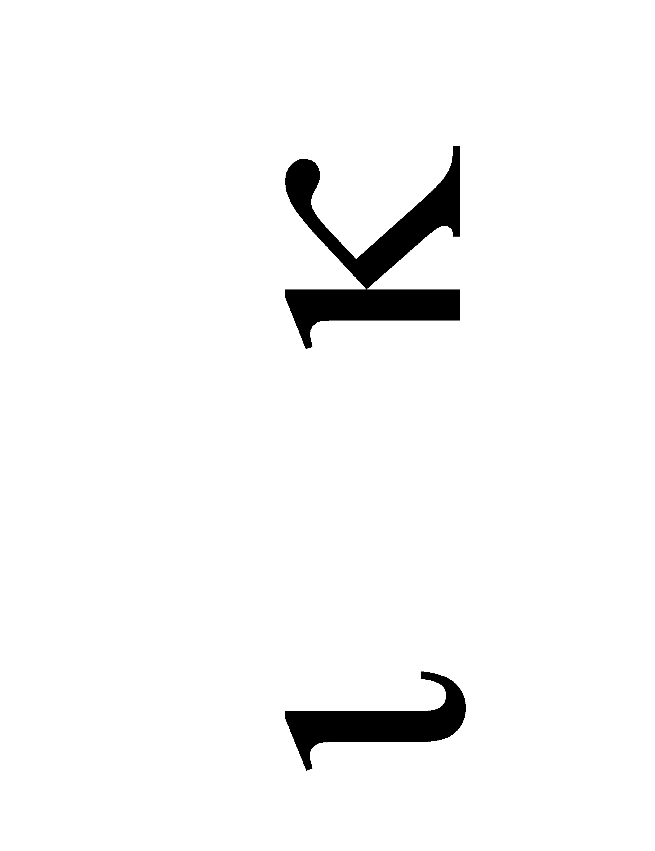
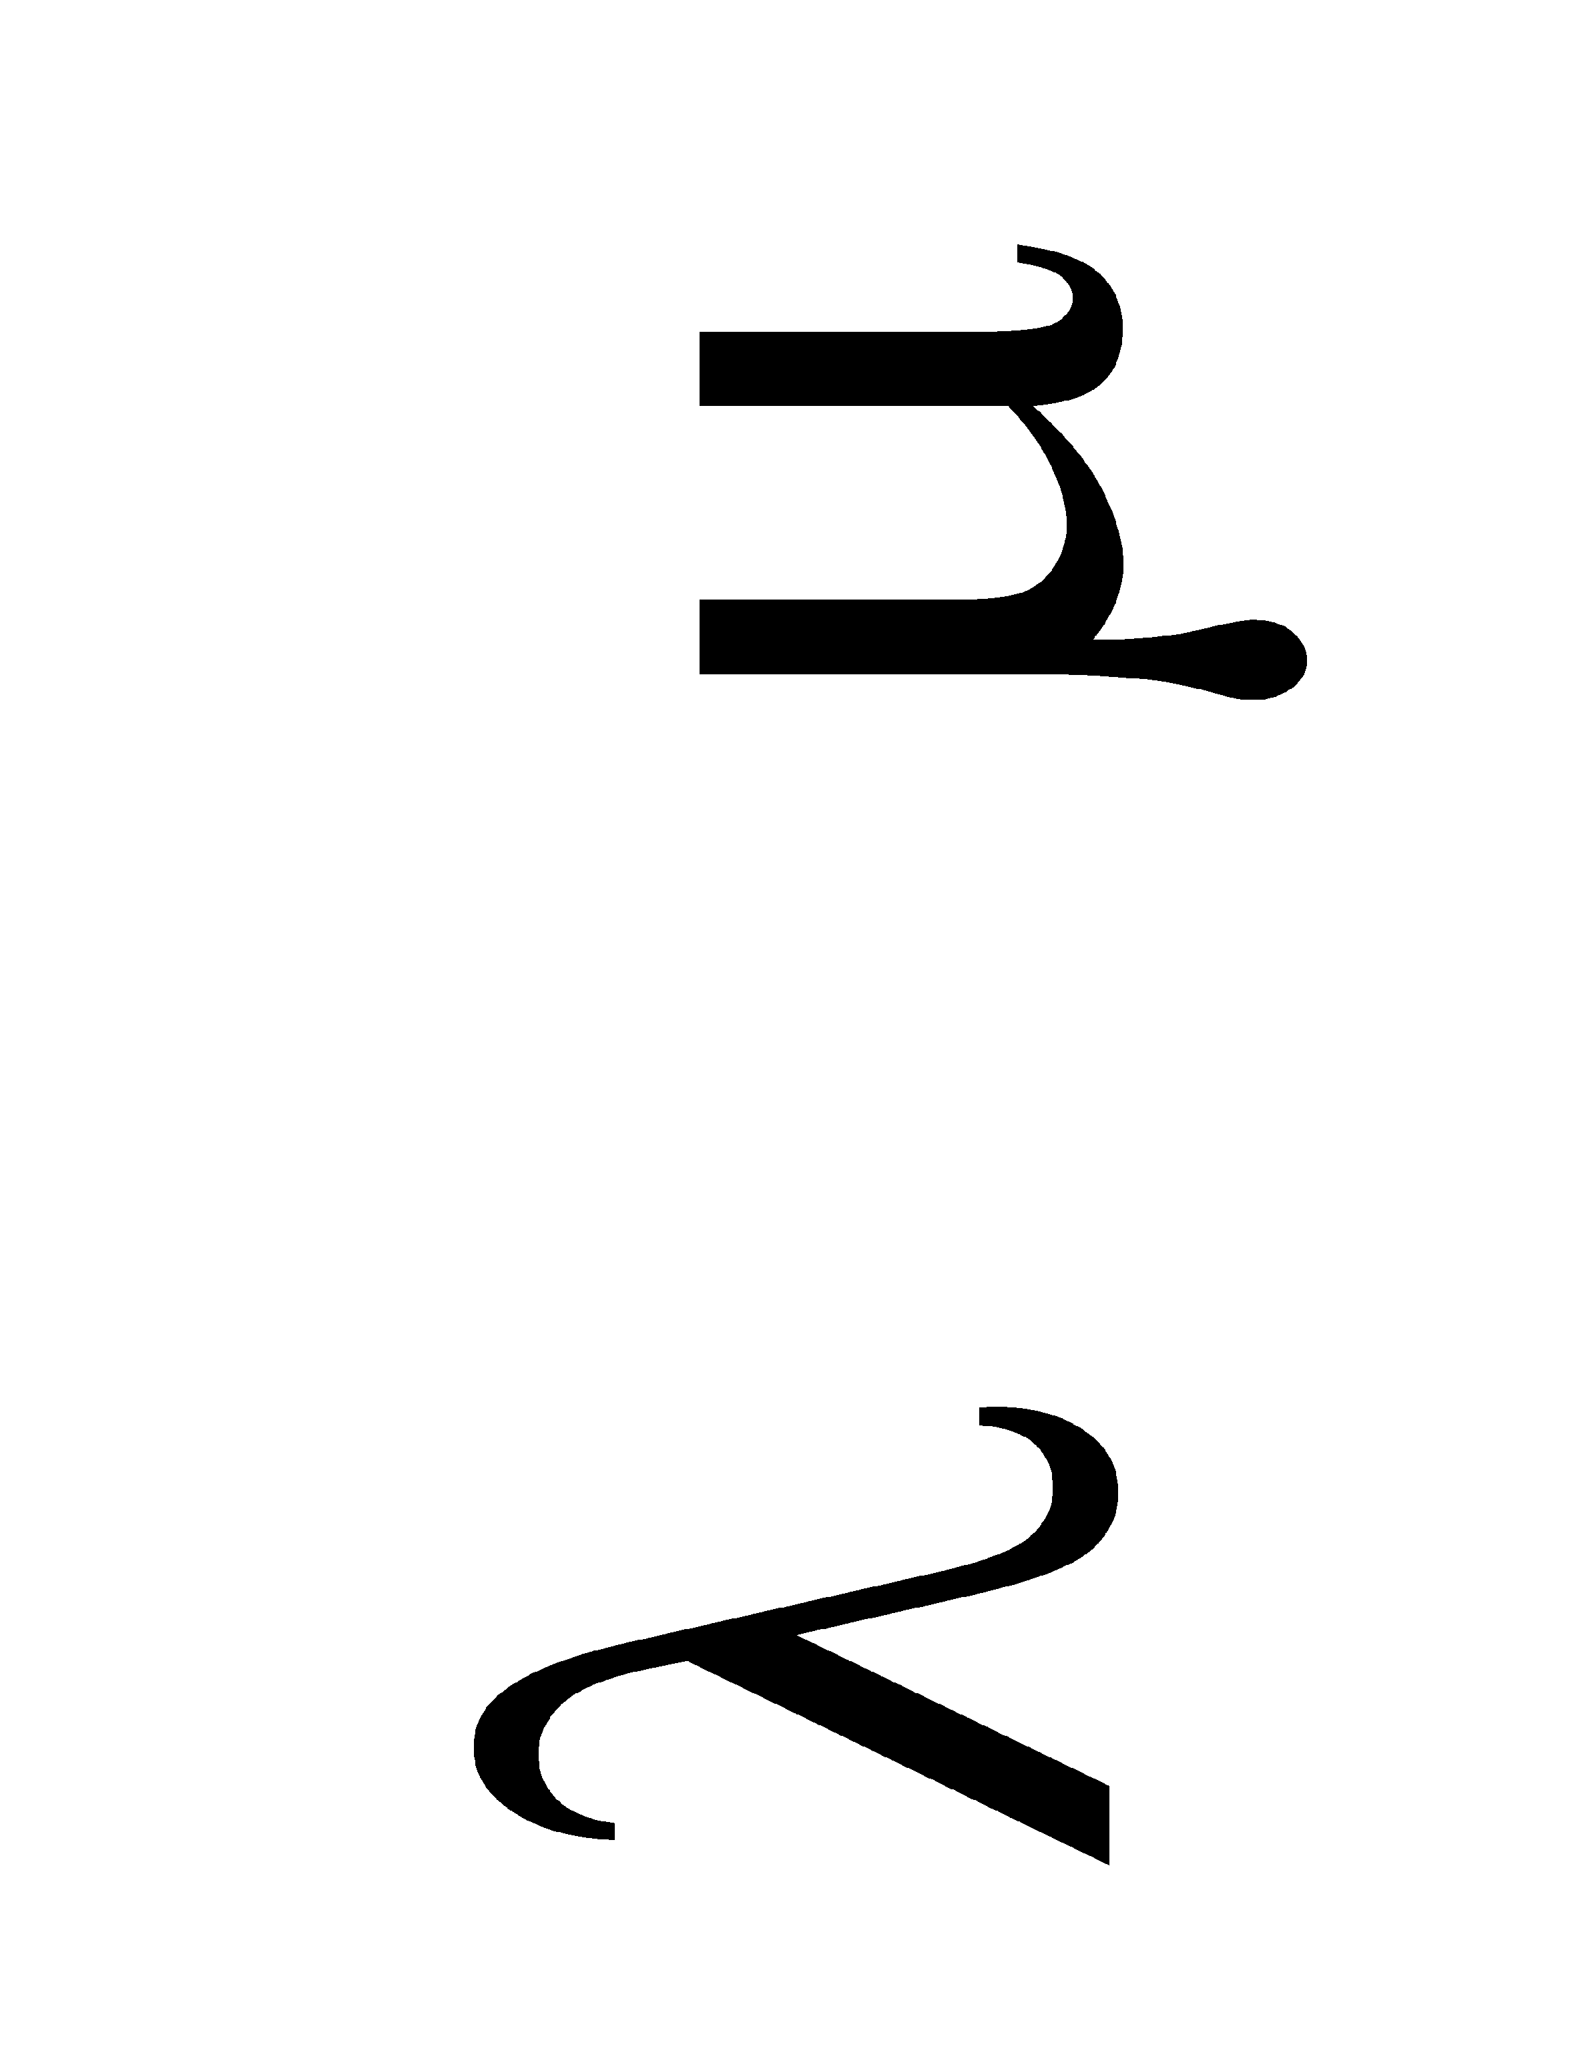
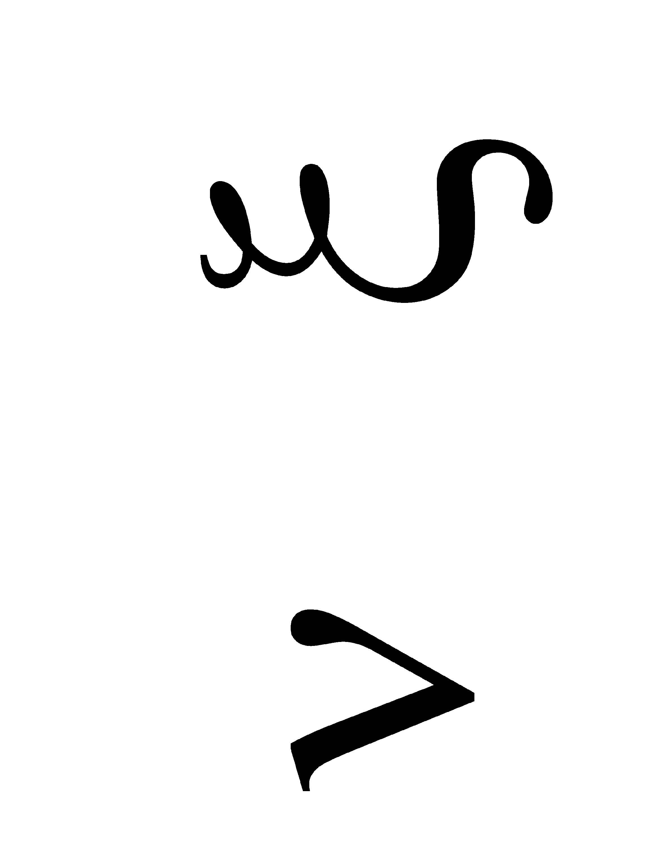
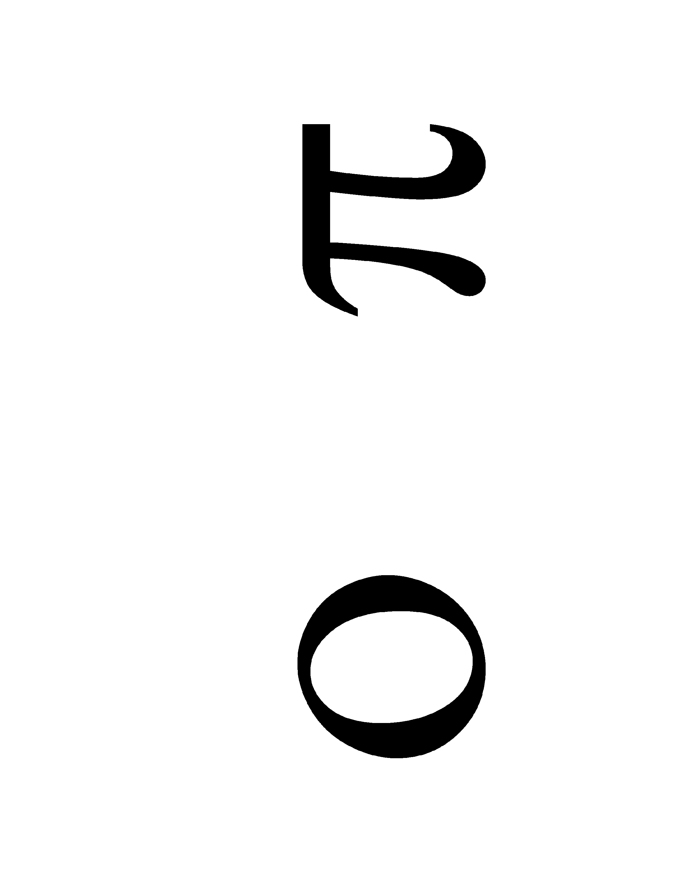
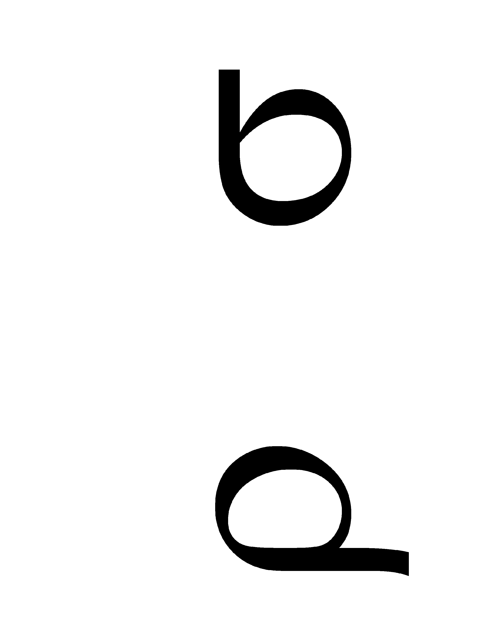
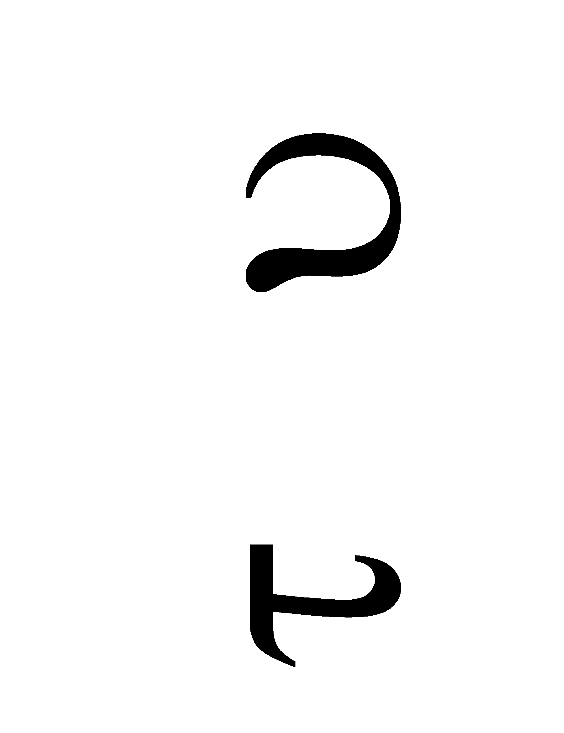
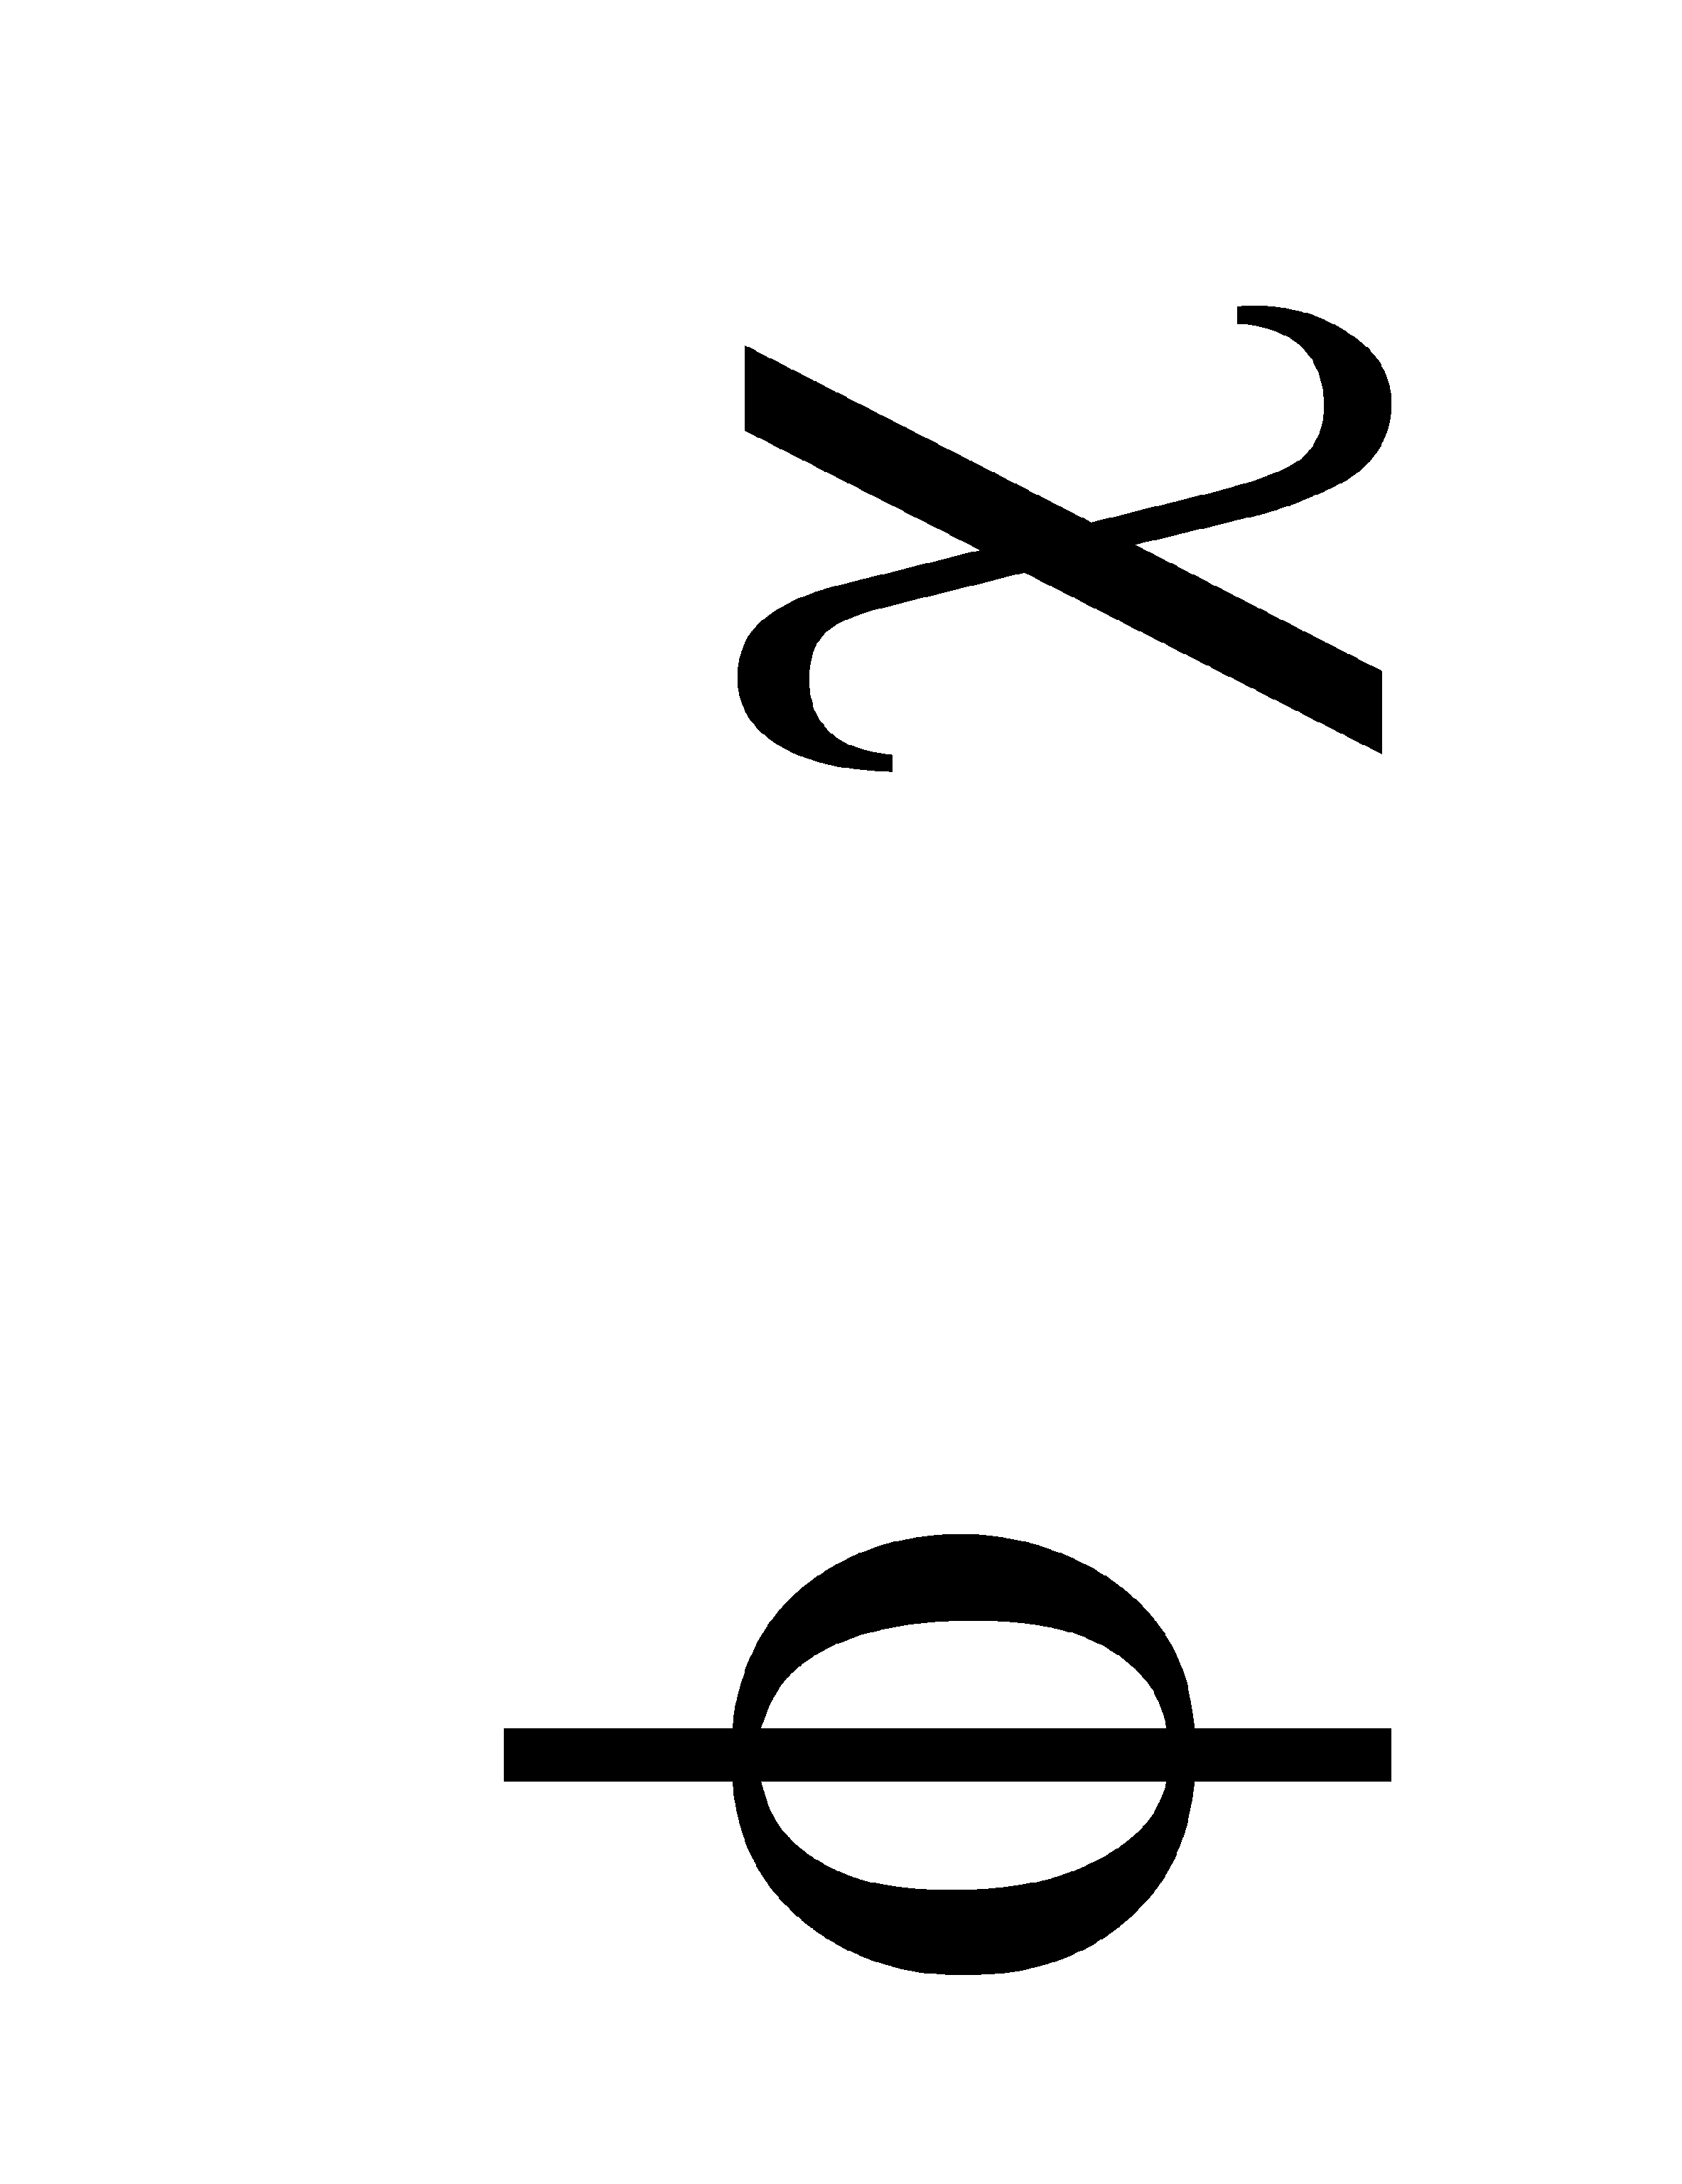
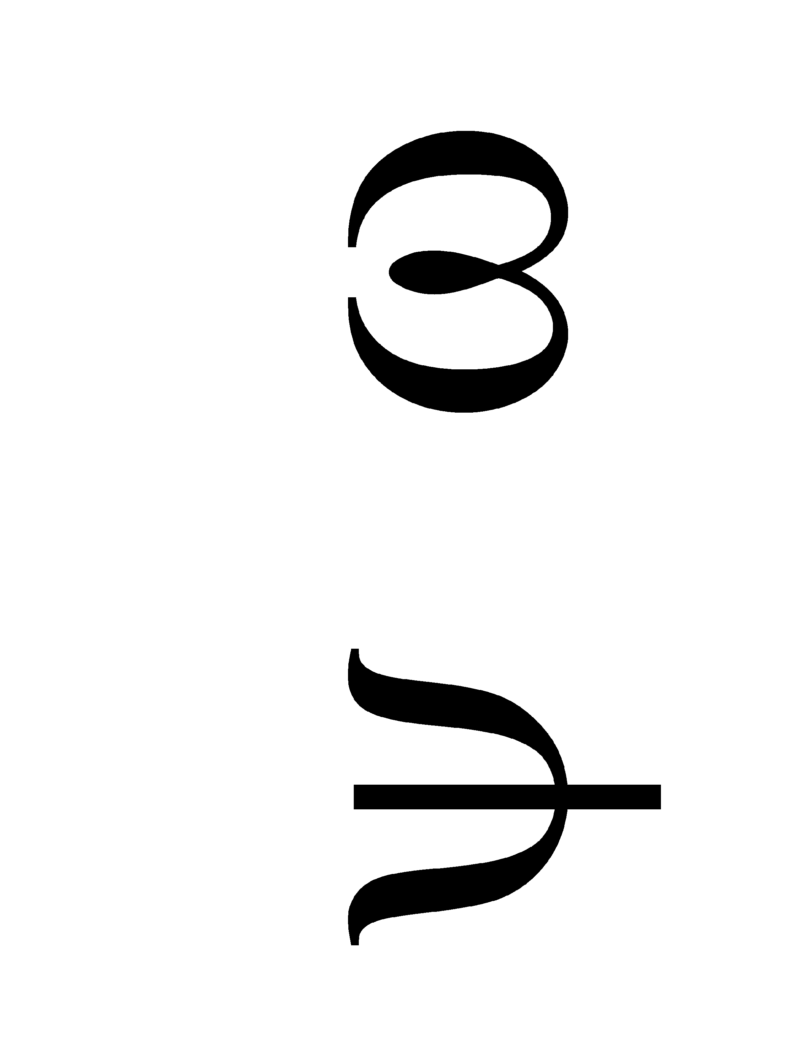
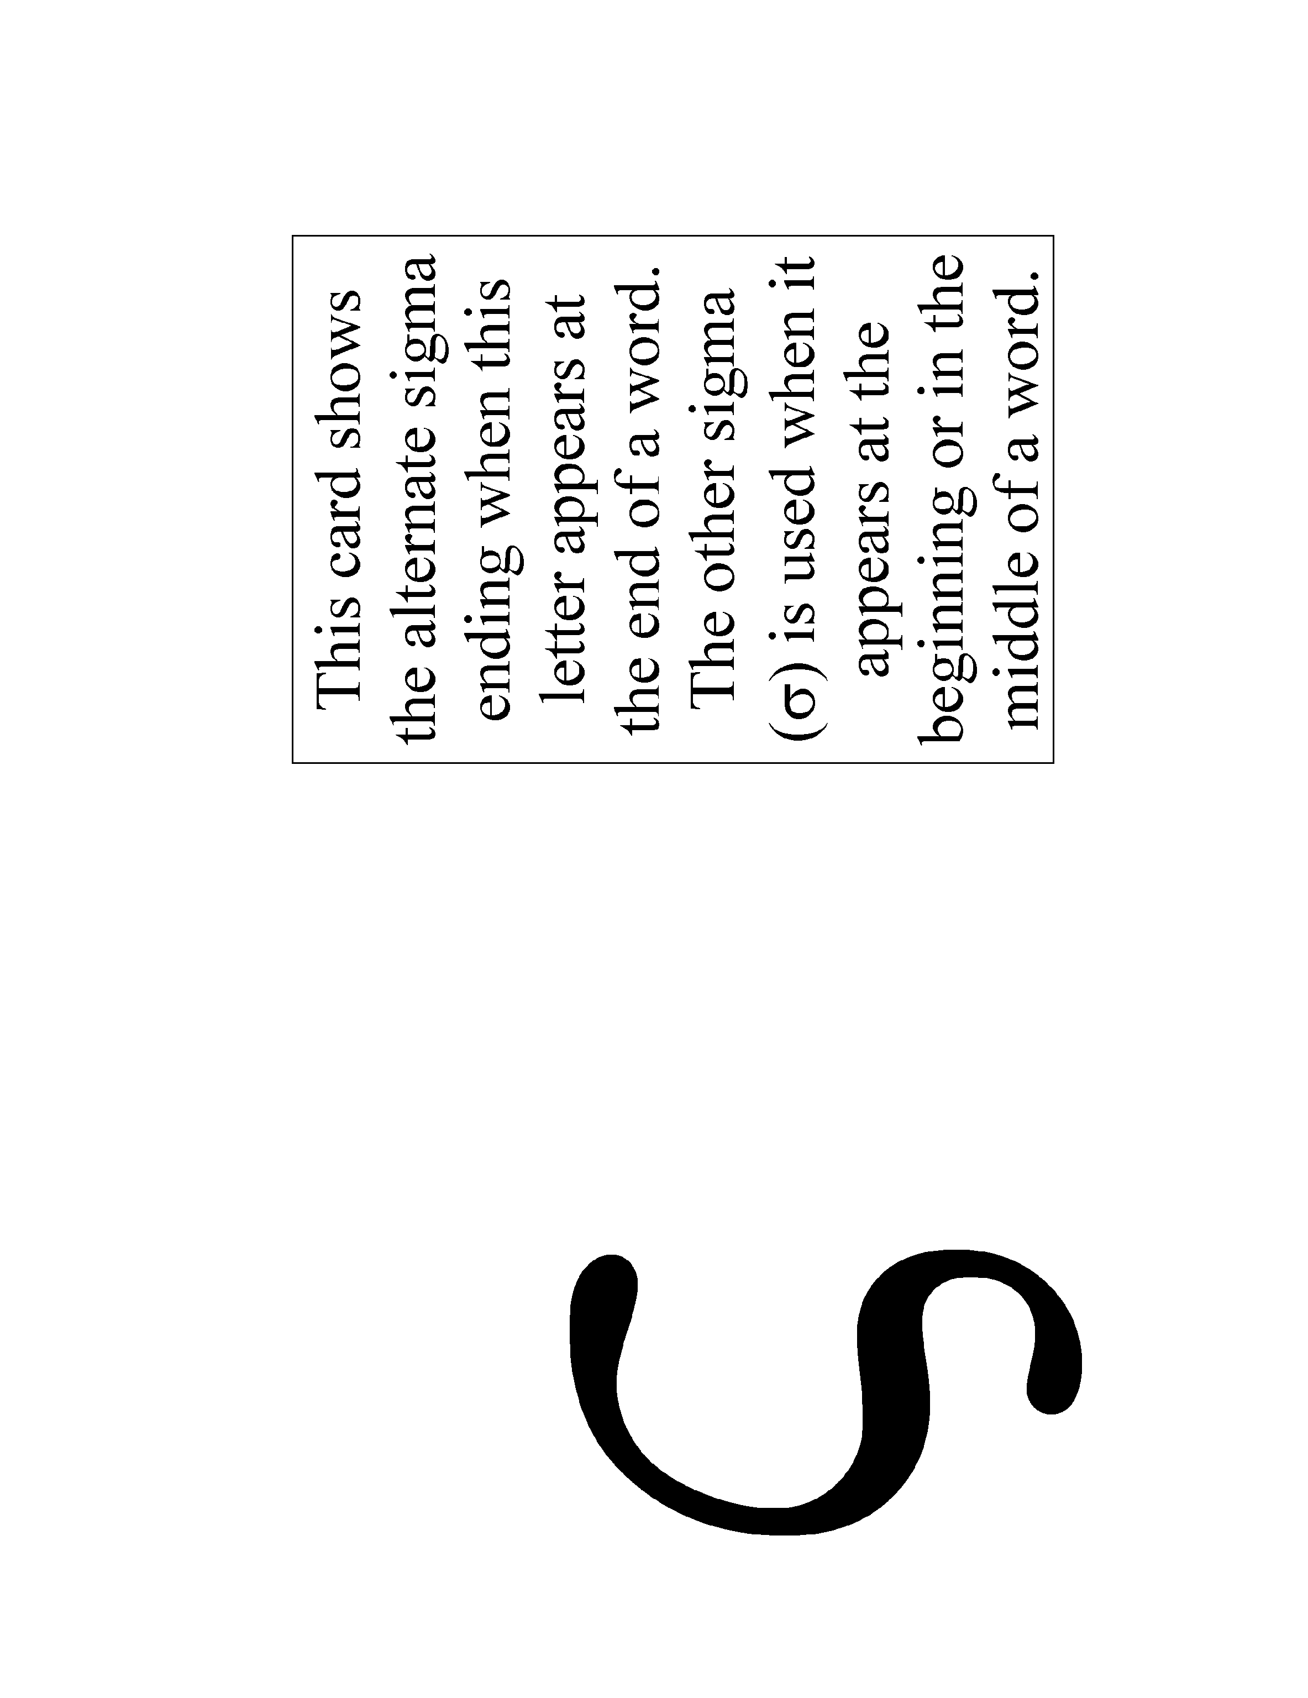
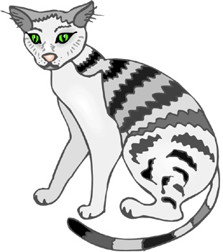 | 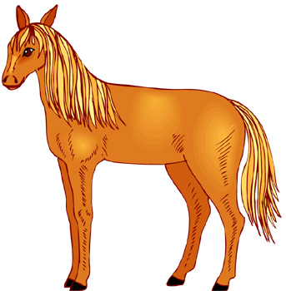
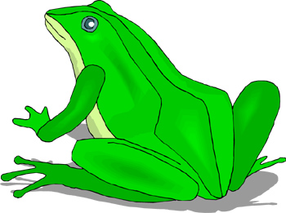 | 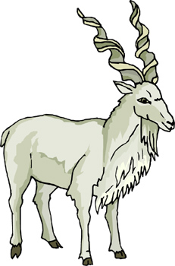
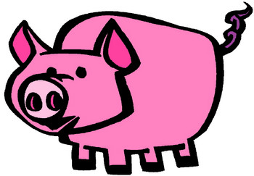 | 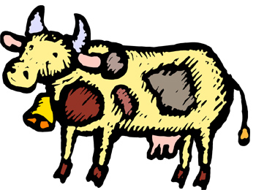
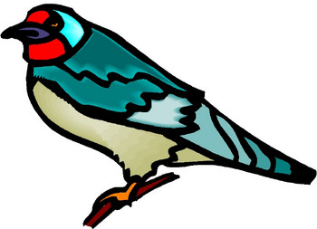 | 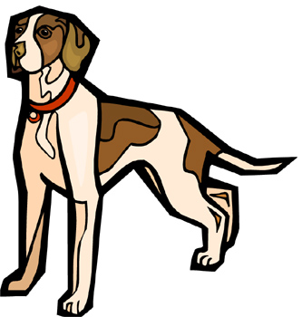
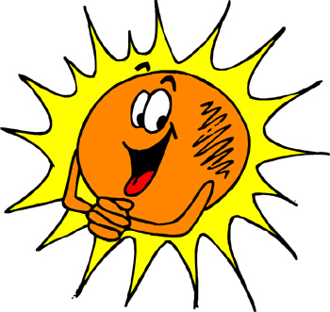 | 
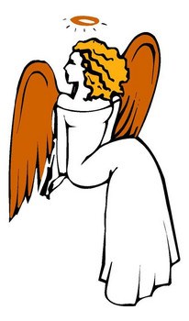 | 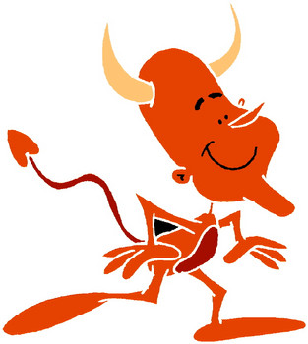
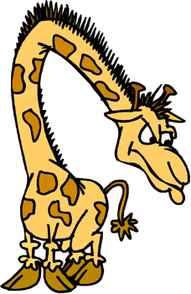
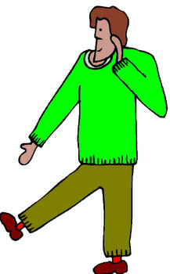 | 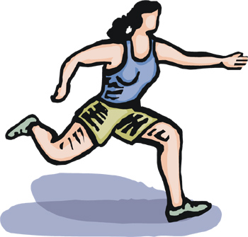
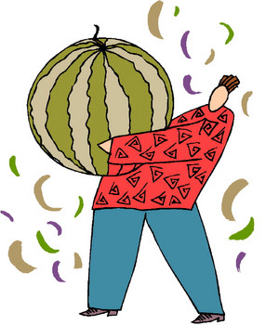 | 



